Student Grading System Final Report

Chen ZhengYuan 1709853Z-I011-0021

1. **Introduction**

This is a Student Grading System which applies functions as following:

Log in and log out: Teachers or students could log in or log out their accounts.

Student account creation (for teacher): The teacher can create an account for each student. The teacher goes to a website and enters the student information into the database.

Management of the assignments (for teacher): The teacher can create an assignment to the students. An assignment has several questions, for each question there is a weight associated with it. There are 5 questions in each assignment and questions are text based. The teacher goes to a website and enters the questions with the title and the weight for each assignment.

Assignment marking (for teacher): When the students submit their assignment, the teacher can give a grade as well as comments for each question and assignment.

Assignment submission (for students): The students can answer the questions online.  Summary of the assignment (for students): The students can see the grade and the comments of their assignments. The system will calculate the total point and display them to the students.

1. **Design (features of system and user manual)**
   1. **Database Design**

**Database:**

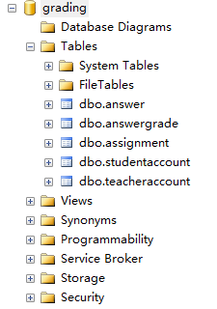

**Teacher Account**

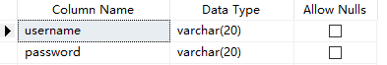

**Student Account**

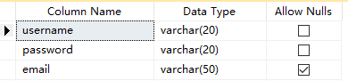

**Assignment**

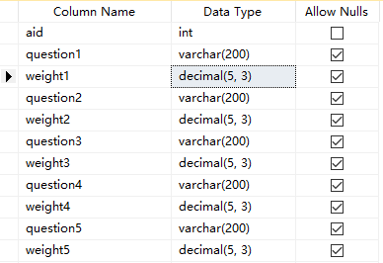

**Answer**

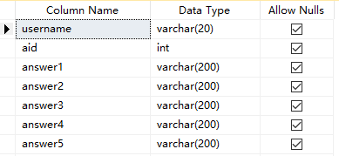

**Answer Grade**

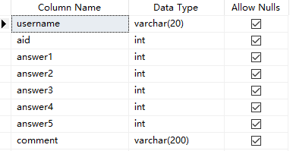

**ER diagram**

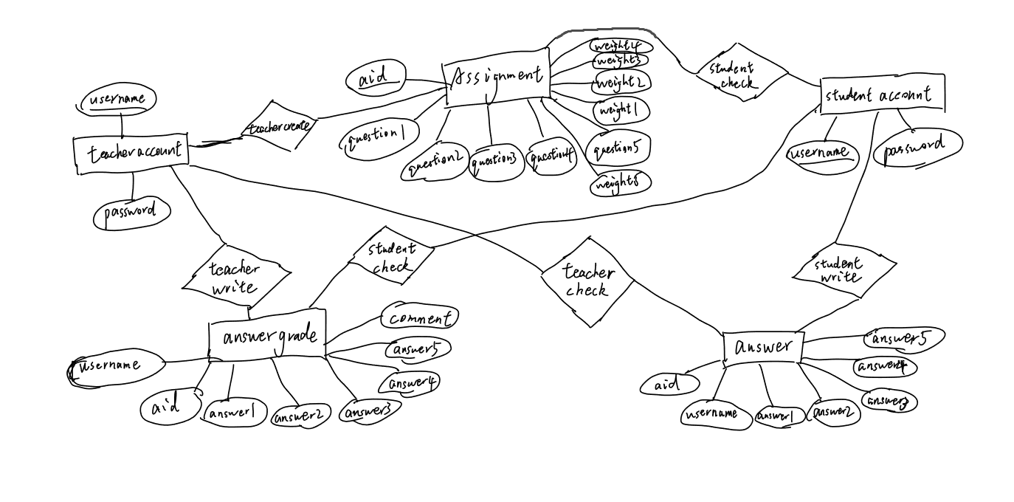

* 1. **Asp.net Design**

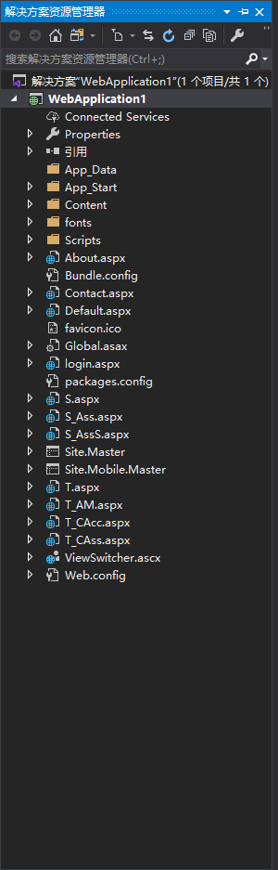

**Login.aspx**

**This is the start page and it is for teacher or student to Log In. Users should enter a username and password then choose the correct identity to log in.**

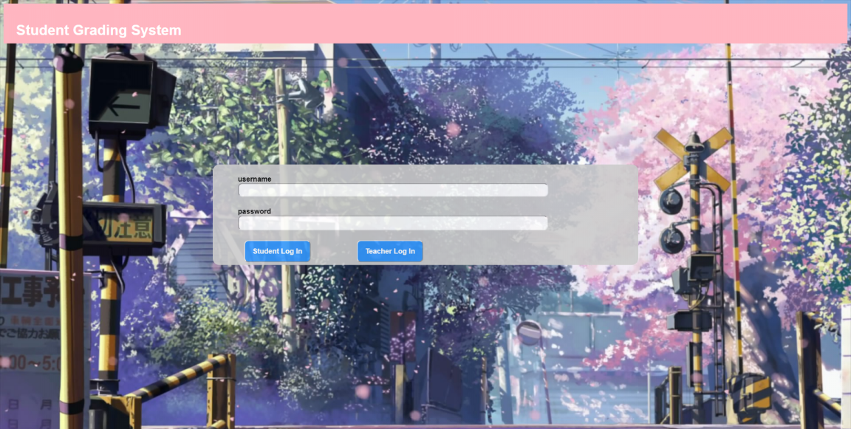

**T.aspx**

**When a teacher logs in, it will jump to this page for teacher to choose a function he is in want of or log out. Functions include creating student account, creating assignment and assignment marking.**



**T_CAcc.aspx**

**This page is for teachers to create student accounts. Teachers could enter the username, password and E-mail of a student and the page would return “success!” if a student account actually been created. When it’s done, teachers could click the back button and choose other functions or just log out.**

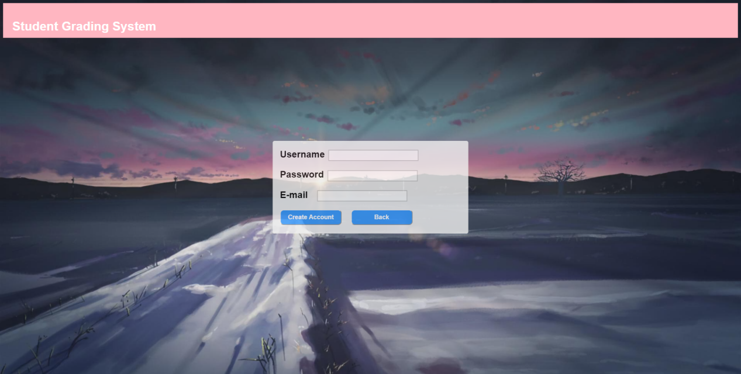

**T_CAss.aspx**

**This page is for teachers to create assignments. Teachers could enter the id of a assignment, 5 questions and their weights for calculating the total points. The weight should be a decimal number between 0 to 1. The sum of weights of 5 questions should be 1 otherwise the page would return a wrong message: “The sum of weights is not 1!”. If teachers want to delete a assignment, he can only enter the id of assignment and click the delete button. The reset button is for teacher to empty all the blanks. When it’s done, teachers could click the back button and choose other functions or just log out.**

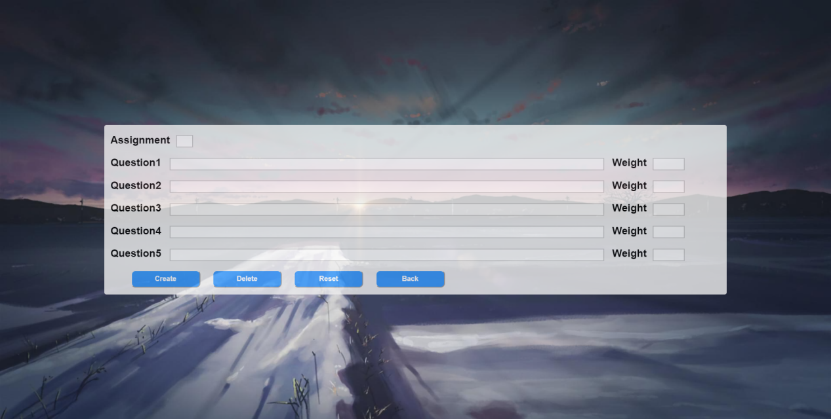

**T_AM.aspx**

**This page is for teachers to mark assignments. Teachers could enter points of each question and write a comment for student. The point should be a integer between 0 and 100. If teachers want to check other answer, he could enter the assignment id and the username of student to enter other answer of student. When it’s done, teachers could click the back button and choose other functions or just log out.**

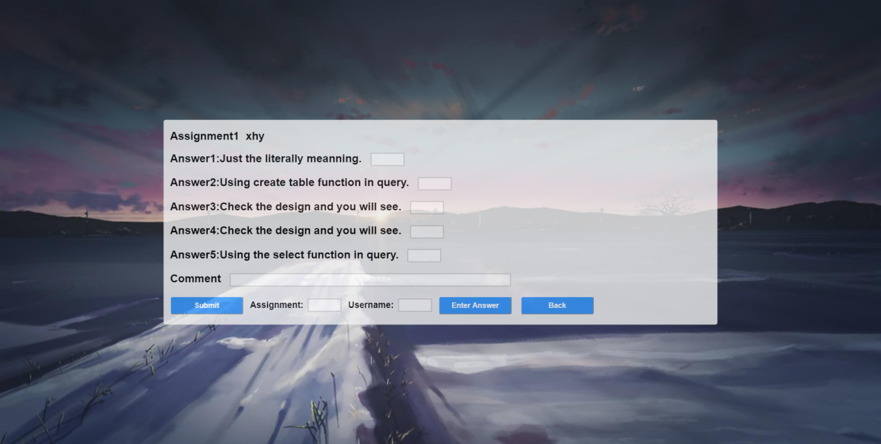

**S.aspx**

**When a student logs in, it will jump to this page for student to choose a function he is in want of or log out. Functions include submitting assignment and checking assignment summary.**

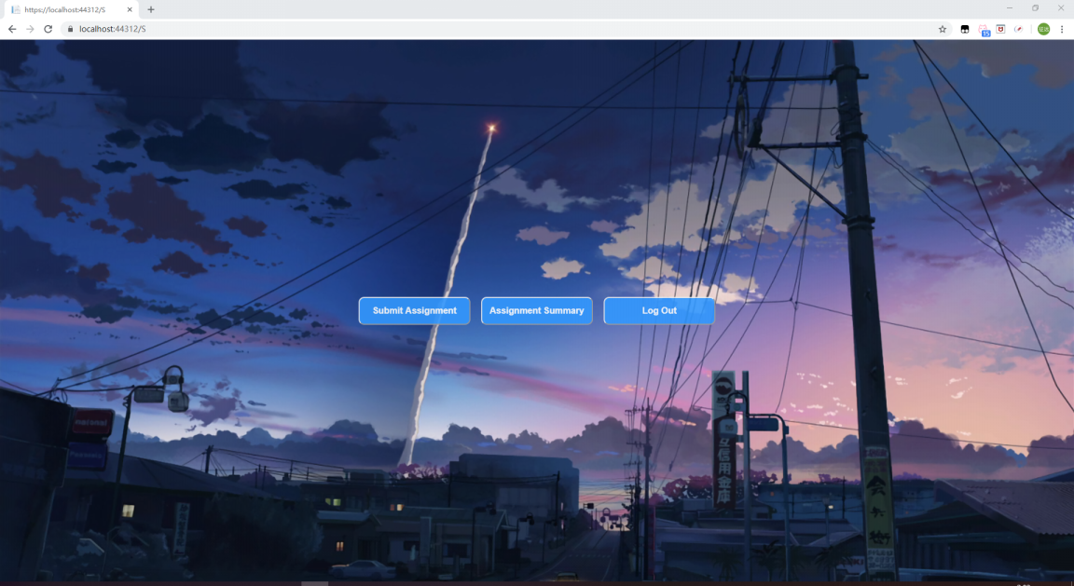

**S_Ass.aspx**

**This page is for students to submit assignments. Students would see 5 questions on the page. They can answer questions and submit the assignment. Students can also enter the id of assignment to enter other assignment. When it’s done, students could click the back button and choose other functions or just log out.**

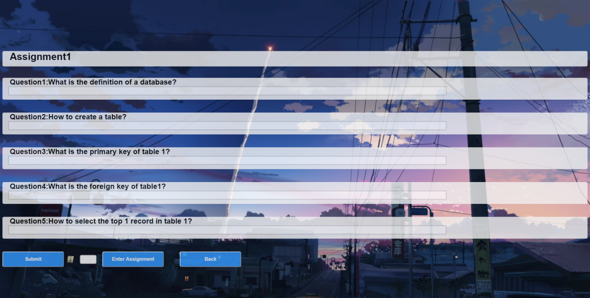

**S_AssS.aspx**

**This page is for students to check assignment summary. Students would see points of each questions, the total point after calculating weight and the comment on the page. Students can also enter the id of assignment to enter other assignment summary. When it’s done, students could click the back button and choose other functions or just log out.**

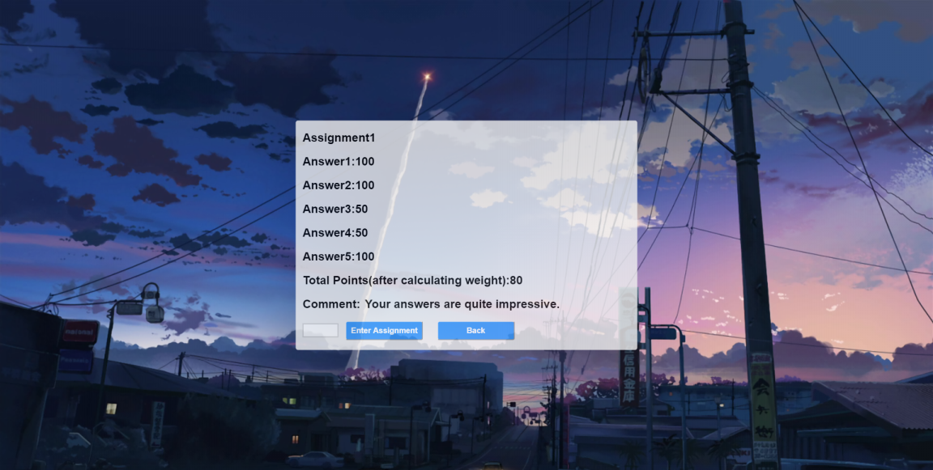

1. **Others**

**The initial teacher account and student account is written in .sql file as well as the whole process of creating database and tables. Description of the queries and transactions are written in the comment in source code as well as the explanation of code fragment.**